Sunday | Monday | Tuesday | Wednesday | Thursday | Friday | Saturday
 |  |  |  |  | 1 | 2
3 | 4 | 5 | 6 | 7  Hanukkah Begins | 8 | 9
10 | 11 | 12 | 13 | 14 | 15 | 16
17 | 18 | 19 | 20 | 21  Winter Begins | 22 | 23
24 | 25  Christmas | 26  Boxing Day (Canada)  Kwanzaa Begins | 27 | 28 | 29 | 30
31

New Year’s Eve

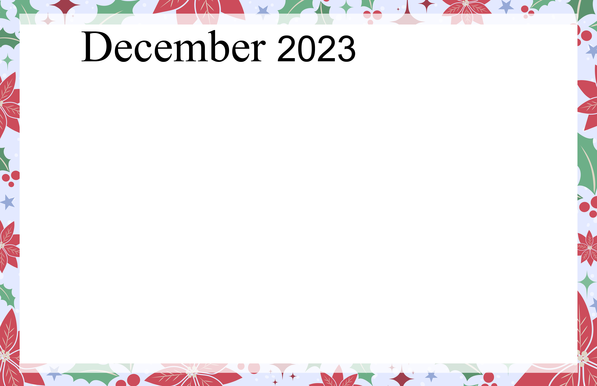  Evergreen Court |  |  |  |  | Happy Birthday Marlene  9:30 Zumba Exercise w/Apphia  11:00 Snoqualmie Casino and Buffet Trip  2:00 Bingo  3:15 Happy Elf Happy Hour | Happy Birthday Mark  9:30 Video Exercises  1:00 Holiday Movie- The Grinch  3:00 Word Searches  Resident Thrift Shop 11-6pm
9:30 video Exercises  1:00 Church Services  2:00 Therapeutic coloring  3:00 Games  Resident Thrift Shop 11-6pm | 9:30 Tai Chi w/ Sophia  10:30 Virtual Travelogue to the North Pole  1:00 Resident Council Meeting  3:00 Bingo | 9:30 Tai Chi W/ Sophia  10:30 Jeopardy Game  1:00 Book Club Discussion  2:00 Group Crossword  5:00 Night time Scenic Drive to see Holiday Lights | 10:00 Trader joe’s  10:00 Christmas Decorating  1:00 Exercise w/ Assured Home Health  2:00 Women’s Tea  3:00 Make Tree Ornaments | Hanukah Begins  9:30 Tai Chi w/ Sophia  10:30 Family Feud  1:00 Hanukah Stories and History  2:00 Music w/ Dan R.  3:00 Spiritual Devotion Group | 9:30 Zumba Exercise w/ Apphia  10:00 Make Ginger Bread Houses  1:00 Bingo  2:30 Happy Hour w/ Cowboy Bob | 9:30 Video Exercise  1:00 Holiday Movie- It’s a Wonderful Life  3:00 Crossword puzzles
9:30 Video Exercises  2:00 Sylvia Fox Caroling group  3:00 Group Therapeutic Coloring | 9:30 Exercise w/ Apphia  10:00 Holiday Card Making  1:00 Men’s Group w/ James  3:00 Bingo | 9:30 Video Exercises  10:00 Brain Teasers  1:00 Book club Discussion  2:00 Word Games  3:00 Make homemade Christmas Presents  5:00 Night Time Scenic Drive to see Holiday Lights | 10:00 Trader Joes  1:00 Exercise w/ Assured Home health  2:00 Hot cocoa social  3:00 Musical Bells w/ Rebecca | 9:30 Video Exercise  10:00 holiday Trivia  1:00 Make Holiday Cookies  3:00 Spiritual Devotion Group | Hanukah ends  9:30 Zumba Exercise w/ Apphia  10:00 Make Latkes  11:00 MOD Pizza  2:00 Bingo  3:15 Holiday Music Singalong | 9:30 video Exercises  1:00 Holiday Movie- Miracle on 34th Street  3:00 Word searches
9:30 Video Exercises  1:25 Seahawks Game  3:00 Group Therapeutic coloring | 9:30 Tai Chi w/ Sophia  10:30 Make Christmas Snowflakes  2:00 Music w/ Jon Pressman  3:15 Bingo | 9:30 Tai Chi w/ Sophia  10:30 Balloon burst word game  1:00 Book Club discussion  2:00 Mexican Train Game  5:00 Night Time Scenic drive Bellevue Botanical Gardens | 10:00 Marshalls  10:00 Wrapping presents party  1:00 Exercise w/ Assured Home Health  2:00 Make Christmas centerpieces  3:00 Collect and deliver toys from holiday toy drive | Sophia’s Last Day  9:30 Tai Chi w/ Sophia  11:00-1:00 Holiday Family Dinner  2:00 Music w/ Erik  3:00 Spiritual Devotion Group | Happy Birthday Julie K  9:30 Zumba exercise w/ Apphia  10:00 Group reading of The Night Before Christmas  1:00 Bingo  2:30 Holiday Party and Music from Rouge | 9:30 Video Exercise  1:00 Holiday Movie- A Christmas story  3:00 Crossword Puzzles
9:30 Video Exercises  1:05 Seahawks Game  3:00 Group therapeutic coloring | Christmas  10:00 Christmas Songs and coffee  1:00 Holiday Movie- Christmas Vacation | 9:30 Video Exercise  10:00 Word games  1:00 Book Club Discussion  2:00 Scenic Drive | 10:00 Safeway  1:00 Exercise w/ Assured Home Health  2:00 Mexican Train Game  3:00 Hot cider and chat | 9:30 Video Exercises  10:00 Cranium Crunches  1:00 How to solve a murder mystery game  3:00 Spiritual Devotion Group | 9:30 Zumba Exercise w/ Apphia  11:00 Outing to the Redmond Café  2:00 Bingo  3:15 Birthday Happy Hour and New Year’s Party | 9:30 Video Exercise  1:00 Matinee-Residents Choice  3:00 Word Searches
9:30 Video Exercise  1:05 Seahawks Game  3:00 Group Therapeutic Coloring | December Birthdays: Dr. appointments Monday, Tuesday, Wednesday 9:00-12:00  Marlene 12/1 12 hour notice to sign up for transportation  Mark 12/2 Signup sheet is at the Front desk, remember to put down the time and address of your appointment.  Julie K. 12/22
Evergreen Court 900 124th Ave NE Bellevue, Wa 980005 (425) 455-4333 All Activities are subject to change

